

**Student Information Sheet**

**Educational Games for Museums Research**

**Why am I being asked to be in this research?**

We want to find out whether the boardgame we have made, Karrawirraparri Journey, is interesting and helps students in [Participant Grade] learn about [Game Subject].

We want to know what you think about the game, so that Karrawirraparri Journey can be improved and any games we make in future are useful for students.

[Number of other classes involved] other classes like yours will also be part of this game testing.

**Do I have to be in this research?**

You do not have to be part of this research if you don’t want to, and you will get to play the game no matter what you decide.

If you do decide you want to be involved, both you and your parent/guardian should talk about the research.

They must sign a consent form to give us permission to record your information.

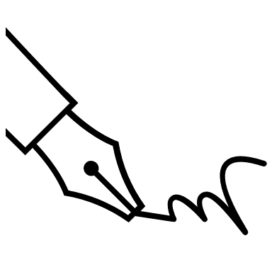  
If you change your mind during the game testing session, you can tell the researcher and they will stop recording your information. You will still get to play the game.

If you change your mind after the session is finished, your information will be anonymous (not linked to your name), so we won’t be able to find it to take it out. Please remember this when deciding to take part.

**What do I have to do as part of the game testing?**

The main thing we will ask you to do is play Karrawirraparri Journey as part of your class.

We will ask you to fill out 2 surveys, one before playing the game and one after.

These surveys will ask you some questions about yourself, and your opinions on the game.

Some of the team will also be coming around to ask for your opinions *while* you are playing the game, and recording those.



On the day, people will also be taking some photos and videos of the game testing, for the researchers to look at after the session is done.

They may also use them as part of any reports or presentations about the game testing, or on social media to promote the game.

If you don’t want your picture or video taken, you can tell one of the researchers or your teacher on the day.

Your parents/guardians can also say no to photos/videos through the consent form.

**Who will get my information?**

****As part of this research, we will collect information about you and your opinions on the game.

All of your information will become anonymous (not linked to your name) after you hand in your surveys.

The people who will have access to your information are:

* The university researcher
* The History Trust of South Australia’s education team

The information you give us will be used to improve [Test Game Title], and help the researcher with her bigger study into game design for learning.

At the end of this larger study, the researcher will get back to your teacher with some results about how your information was used to improve the game.

**Who can answer my questions?**

If you have any questions, you can talk to us, the research team.

You can also ask your teacher or parent/guardians to talk to us.